June 8, 2024

The Canadian Nuclear Association (CNA) appreciates the opportunity to comment on discussion paper DIS-24-02, Proposals to Amend REGDOC 2.13.2 Import and Exports. The CNA has approximately 100 members, representing over 76,000 Canadians employed directly or indirectly in exploring and mining, uranium, generating electricity, advancing nuclear medicine, and promoting Canada’s worldwide leadership in science and technology innovation.
Our comments were prepared after discussion with our members who have extensive experience with imports and exports of nuclear items, controlled nuclear substances, equipment and information. Detailed comments are contained in tables submitted directly by our members; however, CNA would like to highlight several key concerns:
- There is an opportunity to incorporate revisions into the regulation or add information to the associated regulatory document to greatly reduce regulatory burden without increasing risk to nuclear safety by providing general licenses for companies to share controlled nuclear information (not prescribed information per GNSCR) with a country where a nuclear co-operation agreement has been established. At a minimum, this should be put in place for the US and the UK.

- Today’s workplace is very different than when the regulations were first developed. The world now operates through virtual workplaces, virtual meetings and cloud-based systems. The definition of intangible transfer needs to be properly defined to account for these changes, otherwise licensees will face a significant regulatory burden in maintaining and import/export program that doesn’t reflect today’s workplace or provide any security benefit. The CNA recommends a CNSC-Industry workshop to discuss this issue.

- In addition to today’s workplace changes, as noted above, many workers now travel with encrypted devices that may contain controlled nuclear information that is not being shared or transferred to anyone outside Canada. The CNA encourages the CNSC to take the opportunity to modernize the REGDOC to address this issue.

- As well as defining “intangible transfer” our members noted several other opportunities where more guidance would be helpful, including a clearer understanding of what exports require an export licence, the term “complete nuclear reactor” and guidance on how to determine if a document contains controlled nuclear information.

The CNA and its members feel that this discussion document as well as DIS -24-03 could benefit from a CNSC-Industry workshop prior to the drafting of the REGDOCs. CNA believes there are opportunities to further improve efficiency, reduce regulatory burden without compromising security and recommends a workshop to further develop these opportunities.
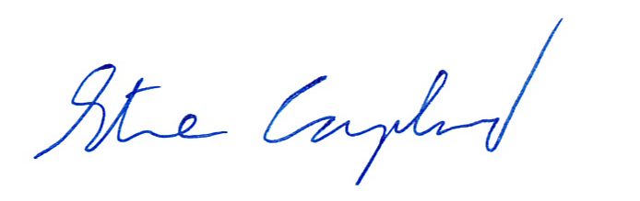
Sincerely,

Steve Coupland
Acting Director, Regulatory Affairs
Canadian Nuclear Association

